Web Api using .Net core with Swagger

Adding swagger
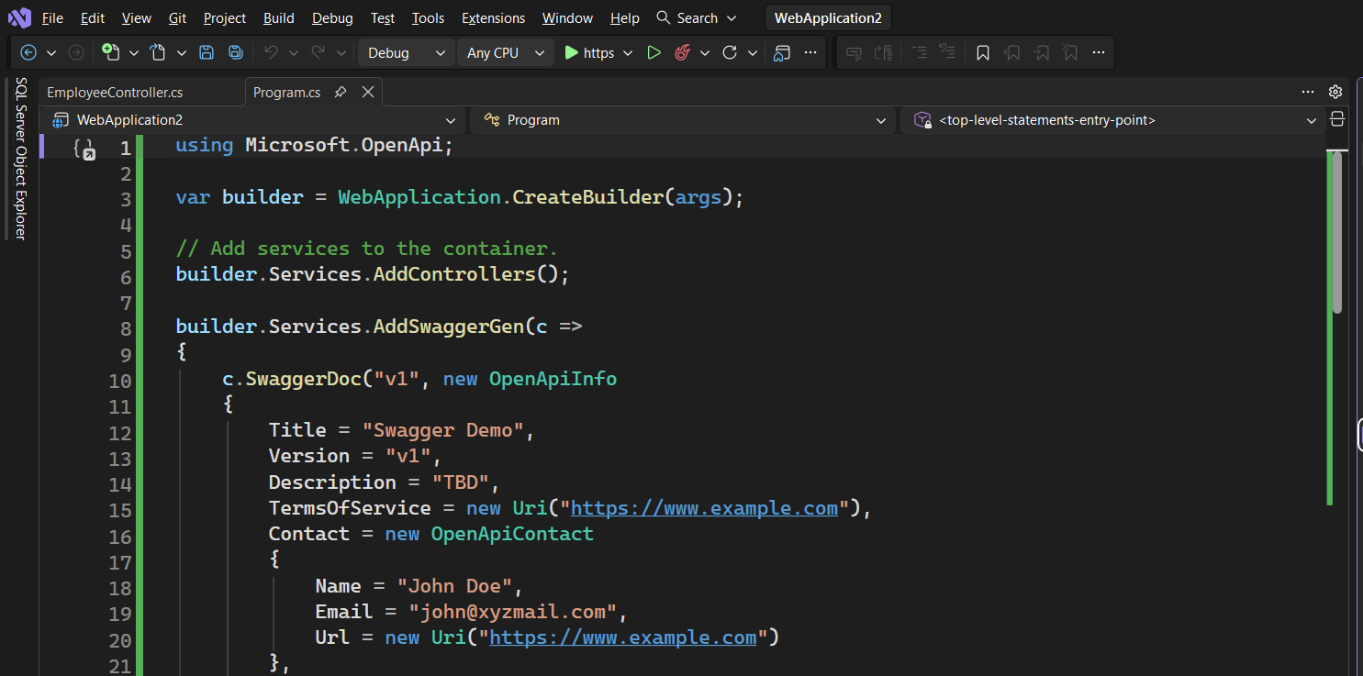

After ValueController , accessing the API URL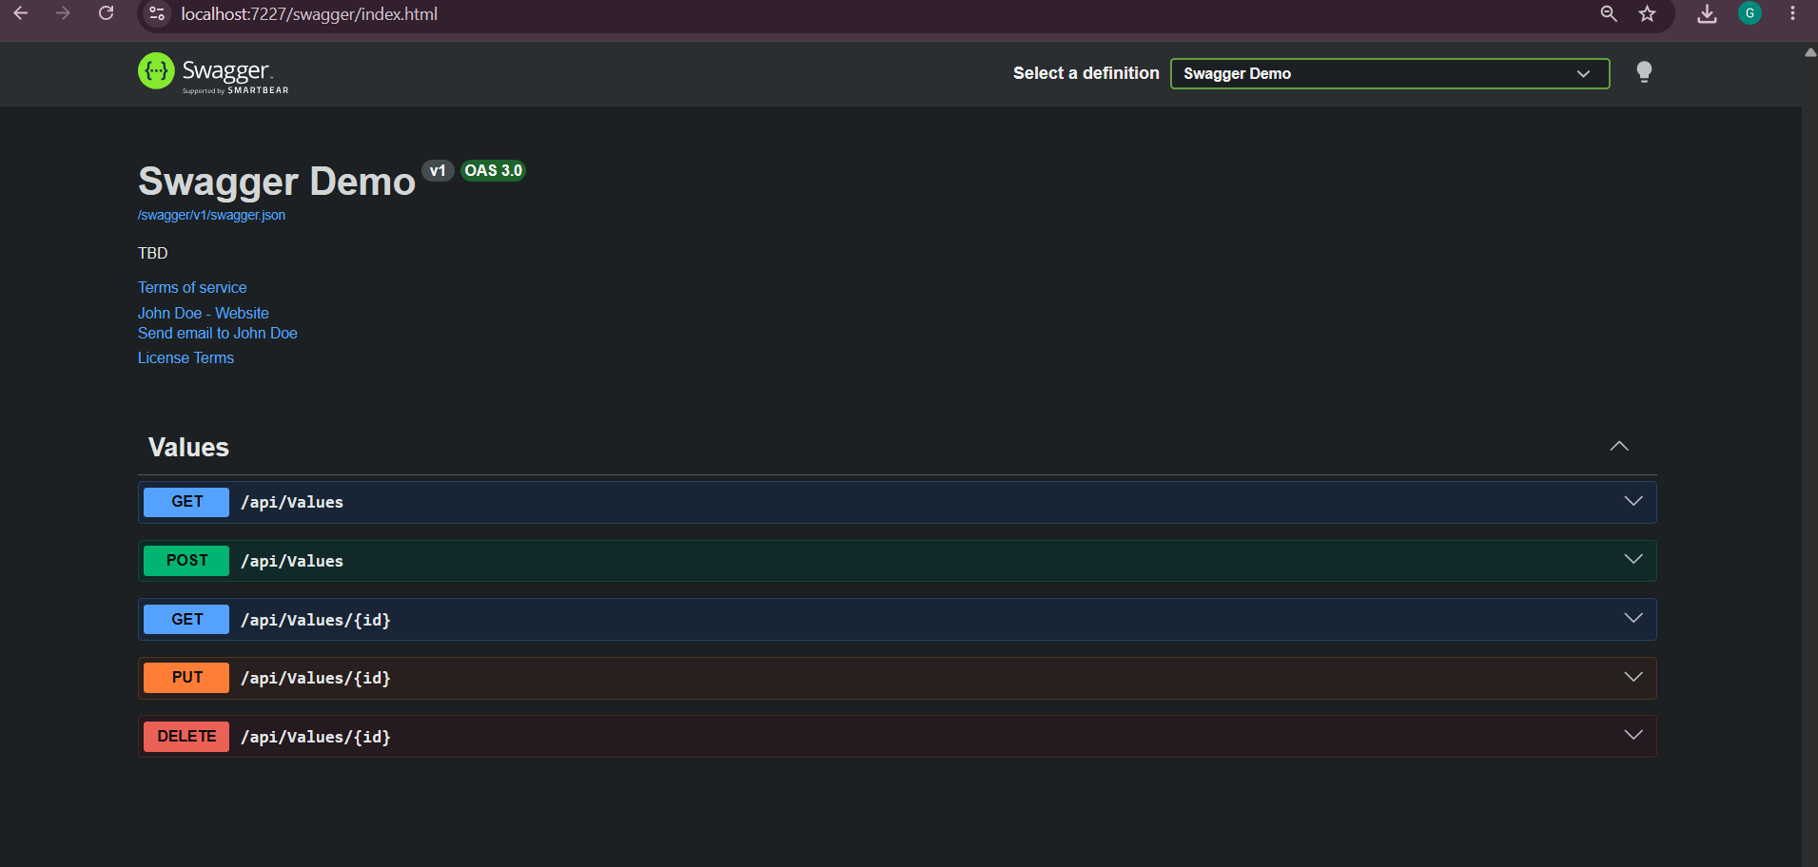

After Adding the EmployeeController , accessing the API URL
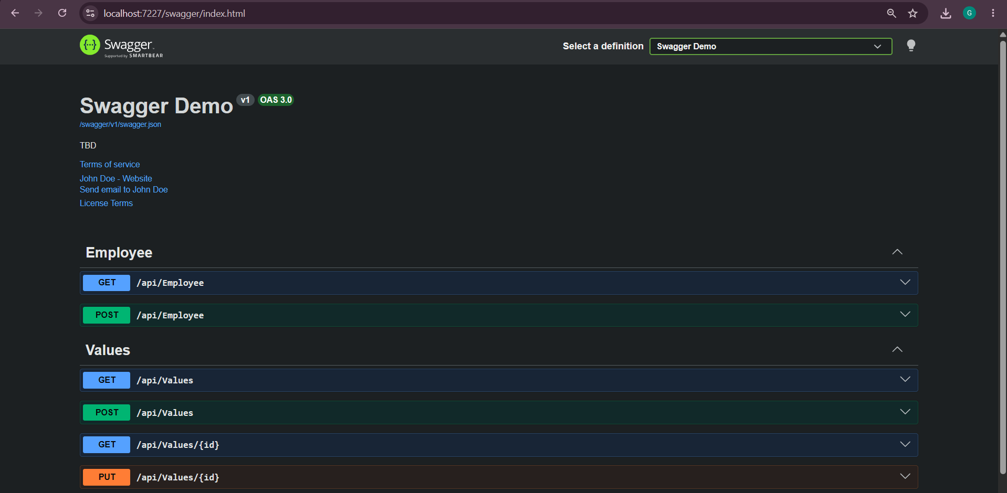

Testing GET req in Postman, got expected result
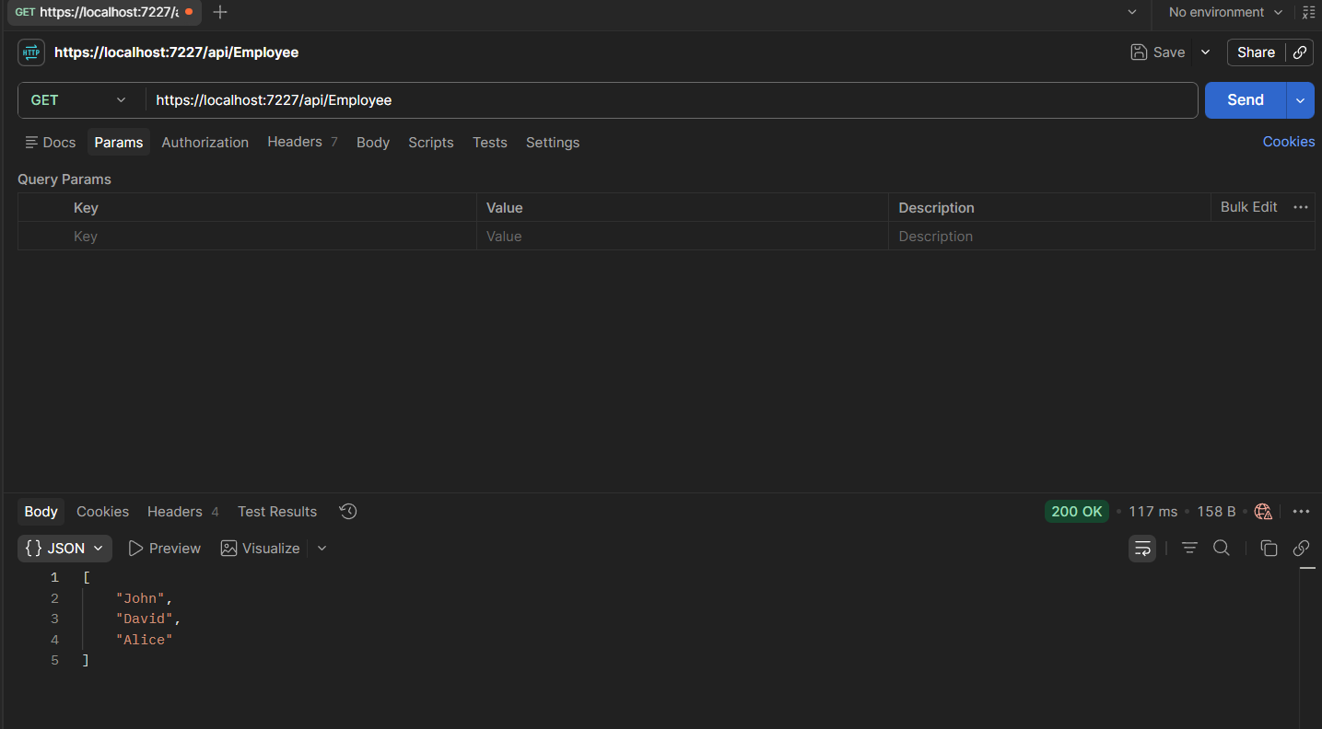

After changing route to api/Emp , and accessing returned with expected result.
